NEW TOWN ELEMENTARY SUPPLY LIST 2023-2024

Kindergarten
Please do not label the supplies with your child’s name.
1 box of 8 thick/fat markers
3 boxes of 24 thin crayons
20 glue sticks
1 pkg. of 3 x 5 white index cards
1 index card box
6 primary (fat) pencils
plastic pocket folders (solid-plain color plastic coated, so they won’t tear)
1 hard plastic pencil box (please label)
- pair of blunt tip kid’s scissors
- fine point black dry erase markers
1 backpack big enough to fit folders (no wheels)
1 Change of clothes including underwear and socks – please label with your child’s first and last name
Families may donate the following school items to the class:
Boxes of facial tissue
Containers of liquid hand soap
Hand sanitizer
1 box gallon-size Ziploc baggies
1 box sandwich Ziploc baggies Playdough

First Grade
4 packages of sharpened pencils
3 boxes of 24 crayons
1 canvas pencil bags w/ 3 rings
4 dry erase markers-low odor, thin, black
4 dry erase markers-low odor, thick, black
1 package pencil top erasers
- box washable markers
- pairs scissors
2 composition journals 2 black and white primary wide ruled
1 Primary Picture Story Journal
4 plastic folders-3 prongs-1 green, 1 blue, 1 red, 1 yellow
1 bookbag-no wheels
5 large glue sticks
2 highlighters-1 yellow
1 package of post-it notes- 3x3 multicolored 1 plastic bag with change of clothes including underwear and
socks-please label all items
Headphones (no earbuds)
Families may donate the following items to the class:
Large boxes of tissues
Box of gallon size zipper bags (Girls)
Bottles of instant hand sanitizer
Bottle of hand soap
Box of quart size zipper bags (Boys)
Containers of play dough (no modeling clay)
Package of stickers

2nd Grade
Backpack (without wheels)
- large supply pouch/box
- yellow plastic folders with 3 prongs and 2 pockets
2 composition notebooks
2 plastic folders (1 blue, 1 green)
2 packs of #2 pencils (24 count)
4 Dry erase markers (any color)
2 large pink erasers
2 pairs of scissors
6 glue sticks
2 yellow highlighters
2 boxes of 24 crayons
1 art smock or old t-shirt
1 pair of headphones
1 plastic bag with change of clothes including underwear and socks – please label all items

Families may donate the following items to the class:
extra glue sticks, large boxes of tissues,
1 package of large post-its, box of zip-top bags GALLON & SANDWICH SIZE, containers of anti -bacterial wipes
pump bottle of antibacterial hand sanitizer

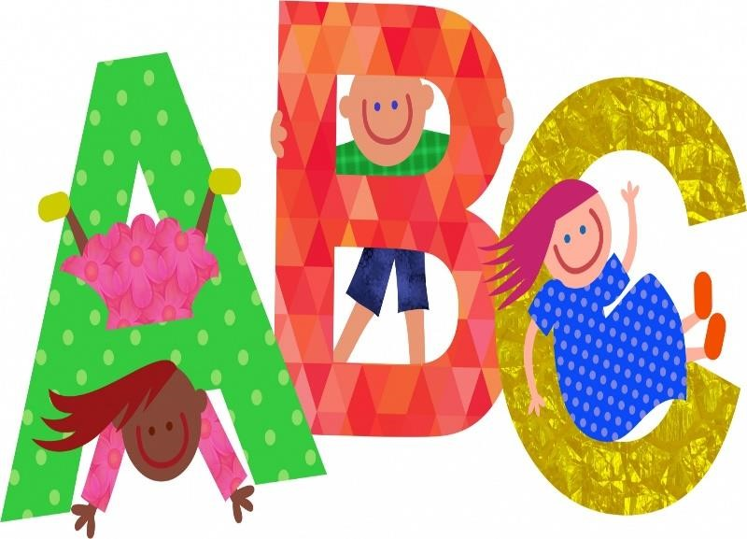

NEW TOWN ELEMENTARY SUPPLY LIST 2023-2024

3rd Grade
1 pack of 5 Dividers (students need to be able to write on tabs
60 #2 Sharpened Pencils (no mechanical pencils)
5 Plastic 3-Hole folders (red, green, blue, yellow, purple)
1 Pair of blunt/Kid’s scissors
1 Headphones (NO EARBUDS)
6 Big Erasers
4 pack Highlighters (multicolored preferred)
2 packs Wide Ruled Loose-Leaf Paper (not college rules)
- Pack Post-it Notes (Light colored preferred)
- packs 24 Crayons
- Change of clothes (pants, shirt, socks, underwear)
12+ Skinny fine tip black dry erase markers)
- Composition books 1 pack or 4-8
Families may donate the following items to the class:
large boxes of tissues disinfecting wipes bottles of antibacterial hand sanitizer roll of paper towels sandwich zipper baggies quart zipper baggies gallon zipper baggies.

4th Grade
4 wide-ruled spiral notebooks with holes
1 box of crayons
2 packs of index cards
1 box-colored pencils
1 school supply bag with holes for binder (no boxes, please)
4 wide-ruled spiral notebooks with holes
1 pack of highlighters (multi-colored)
- package of erasers
- boxes of 24 #2 pencils (no mechanical pencils)
1 pair of scissors
1 pack of colored pens
6 glue sticks
8 dry erase markers – any color (low odor)
7 pocket folders (plastic preferred, with holes) (2 yellow, 2 red, 1 green, 1 blue, 1 purple)
1 pair of headphones (NO EARBUDS)
2 packs of dividers (that can be written on)
- pack of post-its
- packs of wide-ruled notebook paper
1 plastic bag with change of clothes including underwear and socks – please label all items
Families may donate the following items to the class:
large boxes of tissues disinfecting wipes bottles of antibacterial hand sanitizer roll of paper towels sandwich zipper baggies quart zipper baggies
gallon zipper baggies

5th Grade
Dividers (1 pack)
Wide Ruled Notebook Paper (2 packs)
Ink Pens (Black or Blue) (Colors are optional)
1 Spiral Notebook
3 Plastic Folders (orange, yellow, and blue)
Pencil Pouch
Expo Markers
Highlighters
1 Pair headphones (no earbuds)

Families may donate the following items to the class:
large boxes of facial tissues, disinfecting Clorox wipes, sandwich, and gallon sized Ziplock bags

